PSE Pre-Check Instructions:
If you can do a pre-PSE (Photosensitive Epilepsy) pass on the masters, here are instructions below from our Group VP of Engineering/Technology for how to do that.
The following list of companies are approved to run PSE reports in their post houses. You can upload the pass certificates to the portal under the "Photosensitive Epilepsy Certification" category.

Things to keep in mind are:
- You can run the PSE check before before picture is up-rezzed. This can catch potentially problematic shots or sequences before it gets into online.
- When a show delivers, a PSE report will STILL be run along with a TE report, but if you upload the PASS PSE report from your own system, then even if the show FAILS PSE internally, the PASS report that you uploaded to the portal will still be accepted and the show will be NOT be required to go through any additional fixes.

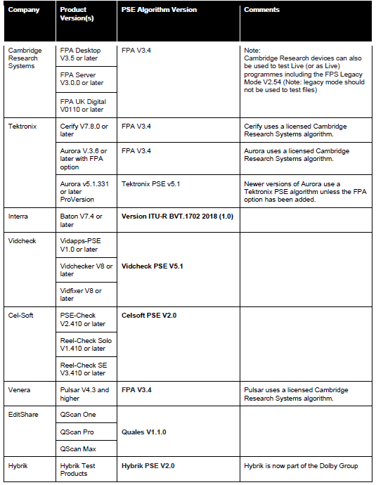

We run Vidcheck V8 and Tektronix Aurora V 6.7 in our supply chain, but there are six other families of test software that will work.
Four of them (at least) are available on a subscription basis or can be consumed through the cloud:
- Hybrik (owned by Dolby) - https://professional.dolby.com/technologies/cloud-media-processing/qc
- Telestream Qualify (Uses the same algorithms as Vidcheck) - https://www.telestream.net/telestream-cloud/quality-control.htm
- QSCAN (I haven't used this one, but have seen it, the "Pro" version does PSE tests and is accepted) -https://lwks.com/qscan/
- Interra Baton (We use this product, but not for PSE) - https://interra.cloud/
I have contacts for all of these suppliers and can help out producers if they want to start up an account. I'm best connected with Telestream, but know all of them. Please let me know how else I can help.

