Guidelines for Discovery Global Budget Template- Excel Version
You will find 4 tabs available in this excel document, which are as follows:
- Assumptions – Summary of budget information and production details.
- Budget Detail – Detailed breakdown of budget
- Budget Summary- Summary of budget breakdown
- Master COA (Chart of Accounts) – Reference list of all budget cost categories and sub-categories.
In a separate file you will also find a standardised production and viewing schedule, which is to be completed (guidelines below) to accompany the global budget template.
Assumptions Tab
First step complete these two boxes on the Budget Assumption tab. This is essential to completing your budget.  Please use numbers to define the version of the budget.  Select your budget region based on the location of the Originating Network you are producing for.  Select your currency based on the main currency of your budget and the main currency you want to be paid in. | 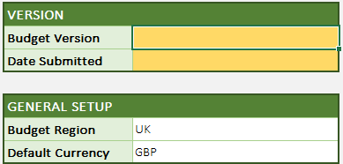
The exchange rates default to Discovery plan rates, set each year. If you have agreed a specific rate with your Discovery Production Manager, you can use the override cell to input the exchange rate agreed. | 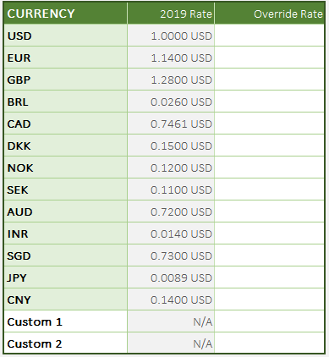

Assumptions Tab Cont.
Complete the main information section. Any cells in yellow must be completed otherwise the budget will be rejected when you upload your budget to the Producer’s Portal.

You may wish to complete the rest of the Assumption tab once you have completed the Budget Detail, as some information will be taken from that feature.

Please ensure you complete as many of the fields on the budget assumption tab as possible, where relevent to your production. This will provide your Discovery Production Management team with the information needed for a budget review.

Budget Detail
This section is guided by the Discovery Chart of Accounts, which you can refer to in the Master COA tab.

You will not be able to:
- Create your own cost categories or sub-categories
- Add or remove columns
- Rename tabs

To start completing your budget click “Add”. This will open an “Add Record” box, which has fields relating to each column on this spreadsheet – see below:

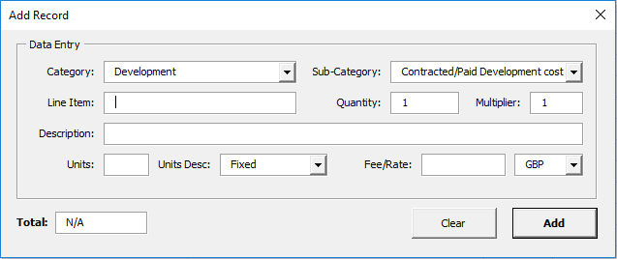
You can select the Cost Category and Sub-Category required from the drop-down menu either by scrolling or typing the name to search. Once you have completed the record click “Add” and the record will appear behind the box in the spreadsheet. You can either continue adding budget line items, or you can close the box and review what you have entered.

If you want to edit a line item, click on the record entry and then click “Edit”. Make your changes and click “update”.

If you want to copy or delete an entry the same process applies.

You can enter records in any order you like, the spreadsheet will automatically group entries by cost category.
Column/Field Name | Definition
Cost Categories | You will need to assign the budget lines to a Discovery Cost Category.
Sub-Categories | We have provided an extensive list of Sub-Categories to build your budget from. Some are more generic than others and will require further info in the line item or description field. You will not be able to add any of your own sub-categories, so please discuss with your Discovery Production Management team if you have any questions.
Line Item | Can be used to give further definition of role or item under the sub-category chosen.
Description | Can be used to give further details for the role or item.
Quantity | Number of that role type or item e.g. if there are two researchers on for same amount of time and rate they can be counted together.
Multiplier | Usually used to capture whether a staff member is full time (1) or part-time (0.5 or 0.25 etc).
Units | Enter number of units (number of days/weeks/months etc)
Unit Type | Choose from our fixed list of units, (weekly, daily, episodic etc..). You will not be able to create your own unit.
Fee/Rate | Enter rate per unit as defined in unit column
Currency | This will default based on the currency chosen on the budget assumption tab. However, you can change this to a different currency if you are working in multiple currencies across your production.

Budget Summary Tab
You can refer to this tab at any point during your budget creation. The main view shows your totals by cost category in the main budget currency.

If you have multiple currencies in your budget, you can click “Show Local Currency” and the summaries will show the currency breakdown.

If you wish to see all sub-categories entered under the cost categories, you can “Expand All Categories”.

For quick reference, if you click on a cost category or sub-category name you will return to that entry in the budget detail tab.

Submitting your Budget
Once budget is complete, save file with following naming convention: | show title_season_ep order_version_ year_budget  (e.g. FunkyMonkey_s8_6x60_v3_2019_budget)
Upload to Producers Portal, under the related Project following the guidelines on page 5.

Schedule
Complete both tabs: Production Schedule and Viewing Schedule.  Fill out schedule template with dates for entire duration of calendar and complete the staffing schedule section highlighted in yellow.  Complete the viewing schedule tab with anticipated dates for viewings and master delivery.  An Example Schedule is available on the Producer Portal | Some important points to note:  You may add rows and columns to fit the needs of your production.  For the staffing schedule, you are free to label the columns based on your staff set up.  Use a 1 to indicate each full working week that staff member is budgeted for, or 0.5 etc to indicate if part time. This allows you to see the total number of weeks you need this staff member budgeted for.
Once schedule is complete, save file as .xls with following naming convention: | show title_season_ep order_version_ year_schedule  (e.g. FunkyMonkey_s8_6x60_v3_2019_schedule)
To upload to Producers Portal | Upload Schedule excel file to producer’s portal under Production Schedule.

