# Great American Country Half Hour Clock

þÿ:30 - Bars & Tone

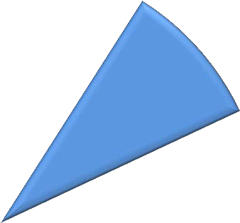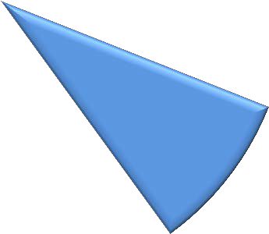

þÿ:20 - Slate

þÿþÿ:10 - Black SEGMENT ONE

þÿþÿ:20 - Black Break SEGMENT TWO

þÿþÿ:20 - Black Break SEGMENT THREE

þÿþÿ:20 - Black Break SEGMENT FOUR

|  |  |  |
| --- | --- | --- |
| **Duration** | **Element** | **Begins @ time code** |
| :30 | Black | 00:58:30:00 |
| :30 | Color bars & tone | 00:59:00:00 |
| :20 | Slate (silent) | 00:59:30:00 |
| :10 | Black (silent) | 00:59:50:00 |
|  | **PROGRAM START** | 01:00:00:00 |
|  | **Segment One** |  |
| :20 | Break One *(black/silent)* |  |
|  | **Segment Two** |  |
| *segments 1-2 must end between 8:00-16:00* | | |
| :20 | Break Two *(black/silent)* |  |
|  | **Segment Three** |  |
| :20 | Break Three *(black/silent)* |  |
|  | **Segment Four** |  |
| :60 | Black *(silent)* |  |
| :20 | Slate for Textless elements at end of the Texted Program Master |  |

*Please Note:*

*Content time only: 20:45*

*(TRT)*

*Content time with black breaks: 21:45*

**Segment Four End @ 01:21:45:00**

# Great American Country Hour Clock

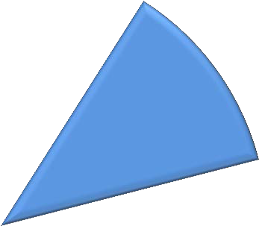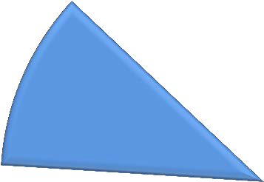

:30 - Bars & Tone

:20 - Slate

:10 - Black SEGMENT ONE

:20 - Black Break SEGMENT TWO

:20 - Black Break SEGMENT THREE

:20 - Black Break SEGMENT FOUR

:20 - Black Break SEGMENT FIVE

:20 - Black Break SEGMENT SIX

:20 - Black Break SEGMENT SEVEN

|  |  |  |
| --- | --- | --- |
| **Duration** | **Element** | **Begins @ time code** |
| :30 | Black | 00:58:30:00 |
| :30 | Color bars & tone | 00:59:00:00 |
| :20 | Slate (silent) | 00:59:30:00 |
| :10 | Black (silent) | 00:59:50:00 |
|  | **PROGRAM START** | 01:00:00:00 |
|  | **Segment One** |  |
| :20 | Break One *(black/silent)* |  |
|  | **Segment Two** |  |
| *content time for segments 1-2 must end between 8:00-16:00* | | |
| :20 | Break Two *(black/silent)* |  |
|  | **Segment Three** |  |
| :20 | Break Three *(black/silent)* |  |
|  | **Segment Four** |  |
| :20 | Break Four *(black/silent)* |  |
|  | **Segment Five** |  |
| *content time for segments 1-5 must end between 30:00-39:00* | | |
| :20 | Break Five *(black/silent)* |  |
|  | **Segment Six** |  |
| :20 | Break Six *(black/silent)* |  |
|  | **Segment Seven** |  |
| :60 | Black *(silent)* |  |
| :20 | Slate for Textless elements at end of the Texted Program Master |  |

*Please Note: Content time only: 41:45*

*(TRT)*

*Content time with black breaks: 43:45*

**Segment Seven End @ 01:43:45:00**