//////////////////////////////////////////////////////////////////////////////////////////////////////////////////////////////////////////////////////////////////////////////////////////////////////
UNIT STILLS GUIDELINES
Production photos play a vital part in getting press and publicity for your program. Images should reflect the same high quality and creativity put into the program itself.
WE NEED HIGH QUALITY, CREATIVE PHOTOGRAPHY TO PROMOTE THE SHOW.
PHOTO SERVICES | photo_services@discovery.com

R E Q U I R E M E N T S
- One-off programs or specials require 60 unique images in total.
- Series require 20-30 unique images per episode.

F I L E S P E C I F I C A T I O N S
- High resolution JPEGs captured with a DSLR camera
- NO SCREEN GRABS OR CELL PHONE PHOTOS
- Image resolution must be at least 300 dpi
  - DO NOT SIZE UP A SMALLER FILE
- Minimum 4000 pixels on the shortest side
- Deliverables should be pre-screened to include only the best of the best images per episode or program deliverable.
- Talent images should be talent approved before delivery
- Post-processing is required for all selects. Please color correct, adjust exposure and crooked horizon lines.
- All images must include required metadata on Photo Caption Log (PCL)

T A L E N T I M A G E S
Various poses and expressions, hero portraits, candid solo and group photos. Close-up, medium and full-length portraits. Show talent in key scenes and interacting with other subjects in the show.
If talent has photo approval rights, only deliver approved images.

S U B J E C T M A T T E R
Images of show content including significant subject matter or scenes that the audience will witness as they watch, talent (clearly see their faces and eyes), contributors, animals, recreations, “before” and “after” for makeovers or reveals, significant vehicles, machinery, props and other key details featured in the program. Provide horizontal photos with some verticals for social. Submit photos from each episode so we can tell the story. Send limited behind-the-scenes (BTS) but please note that equipment being visible does not make a BTS image. BTS images can be talent getting makeup touched up, laughing together between filming or interacting with crew.

D E L I V E R Y
High-res photos (NO SMARTPHONE PHOTOS) and the Photo Caption Log (PCL) must be zipped and delivered via Producer’s Portal so we can start promoting the program as soon as possible.
1Prepare the Photo Caption Log (PCL) with all of the following information:
- Image file name
- Description (aka caption) written as a full sentence with regular case and punctuation.
- Episode Number/Episode Title
- Photographer/Source (third party materials source is the party that provided the images)
- Copyright owner – “Warner Bros. Discovery” for Commission Deals
- Rights Waiver information, if applicable
- Talent notes, if applicable
- Keywords are not required but welcome to be included

Ensure that filenames are typed exactly as seen in filename, including .jpg or .jpeg extension at the end. . We recommend keeping filenames simple, ex: MBFFL_ep401_001.jpg, PMI601_001.jpg

Please note that the Photo Caption Log (PCL) is required and upload will fail without this document. We cannot use the images without this important information.

2 Email photo_services@discovery.com to alert the Photo Services team that you are beginning the delivery process. In the subject line, include the network, full program title and season number.
3 Zip together fully completed Photo Caption Log (PCL) +and photos in a single folder, no subdirectories, and drop in the portal under “Production Stills & Logs” section.
4 Please be aware that delivery may appear to be successful but there is a review period that may result in a failed upload. Keep an eye out for “Image Process Failed” email in the event of a failed upload and try again per feedback from the failed email.
5 The Photo Services team will review if episodes were successfully uploaded and reach out with questions, feedback or concerns. If you have any questions, please feel free to contact the Photo Services team photo_services@discovery.com

G E N E R A L R I G H T S
As outlined in your production agreement, any still photos taken for a Commission will be fully owned by WBD and available for use to promote the program, network and WBD in all media worldwide, and to create ancillary products related to the program (such as home video packaging, merchandising and publishing), throughout the universe, in perpetuity. Any still photos taken for a Co-Production or Acquisition will be used, in accordance with the terms of your production agreement, to promote the program and/or network and/or WBD in all media worldwide, and to create ancillary products related to the program (such as home video packaging, merchandising and publishing) if permitted under your production agreement.

T H I R D P A R T Y I M A G E S
If photos are acquired from a third-party source, such as family archival photos, you must clear rights for use of those photos in accordance with the terms of your production agreement and submit an Acquired Materials Release provided by WBD to make WBD aware of any restrictions. Only deliver images that are cleared for promotion of the program.

Please deliver those documents to the Photo Services team photo_services@discovery.com, If you are
delivering images from stock agencies or wire services, such as Associated Press or Getty Images, please deliver a copy of the invoice that includes rights usage, as well as paid receipts. Do not deliver these additional documents in your zipped file on the Producers Portal.

H I R I N G P R O F E S S I O N A L P H O T O G R A P H E R S
When hiring photographers, secure all rights as stated in your production agreement and provide a copy of the
photographer’s contract when delivering the photos via the Producer’s Portal that outline the rights usage.

E X A M P L E S

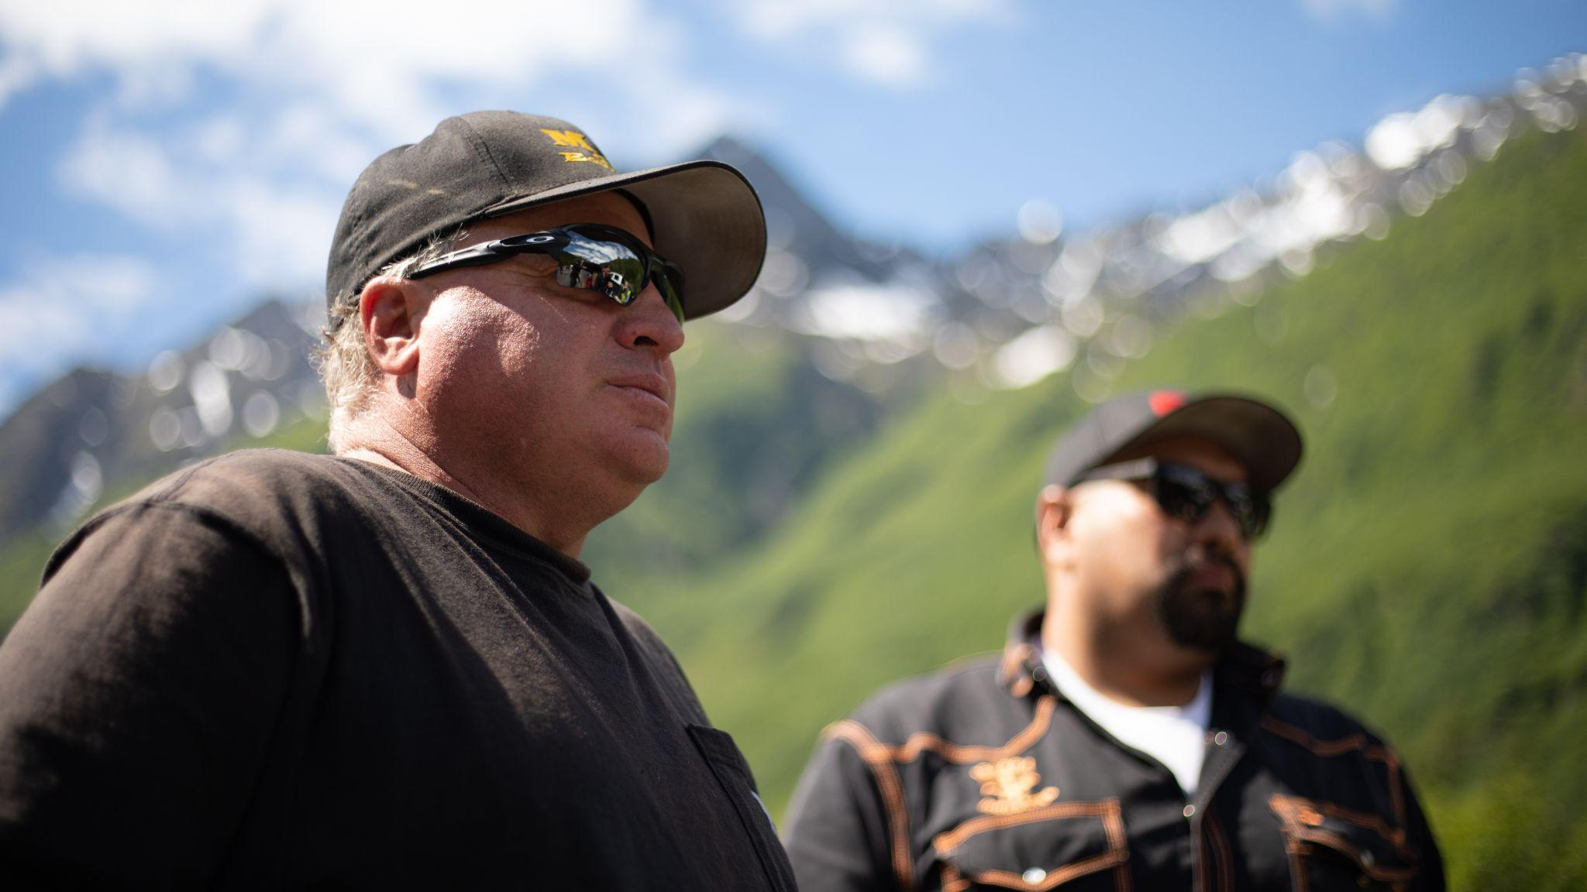  Gold Rush: Freddy Dodge’s Mine Rescue 1B | 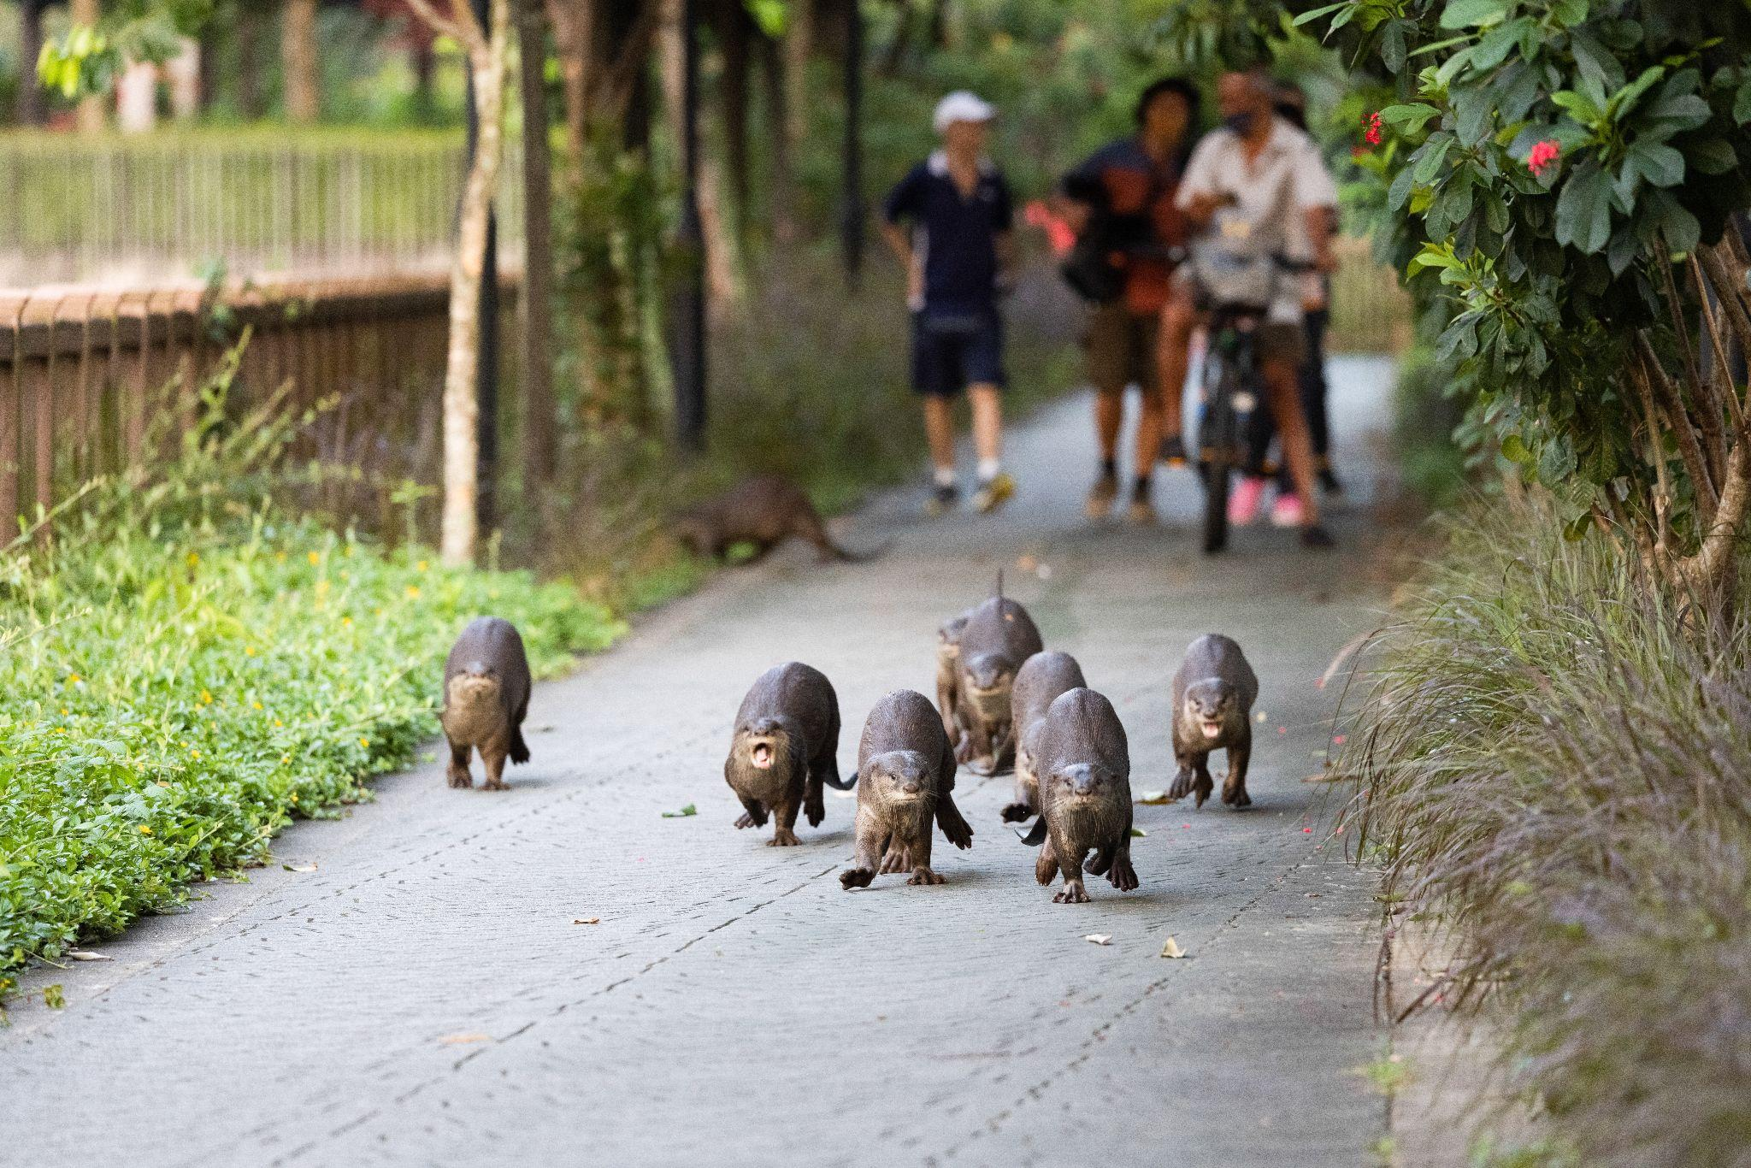  Otter Dynasty
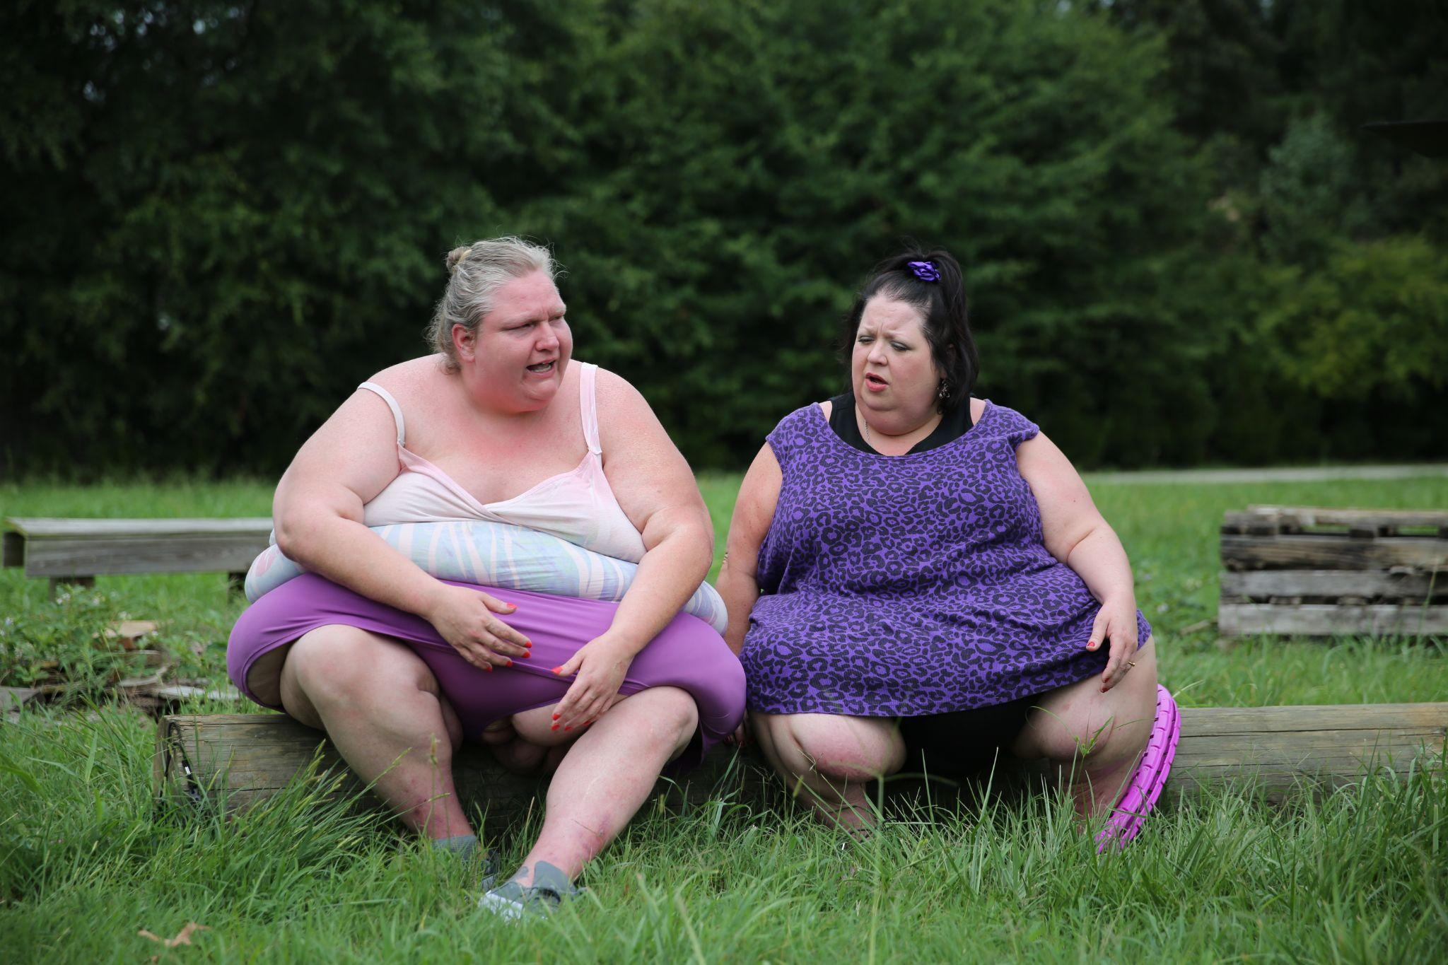  1,000-lb Best Friends | 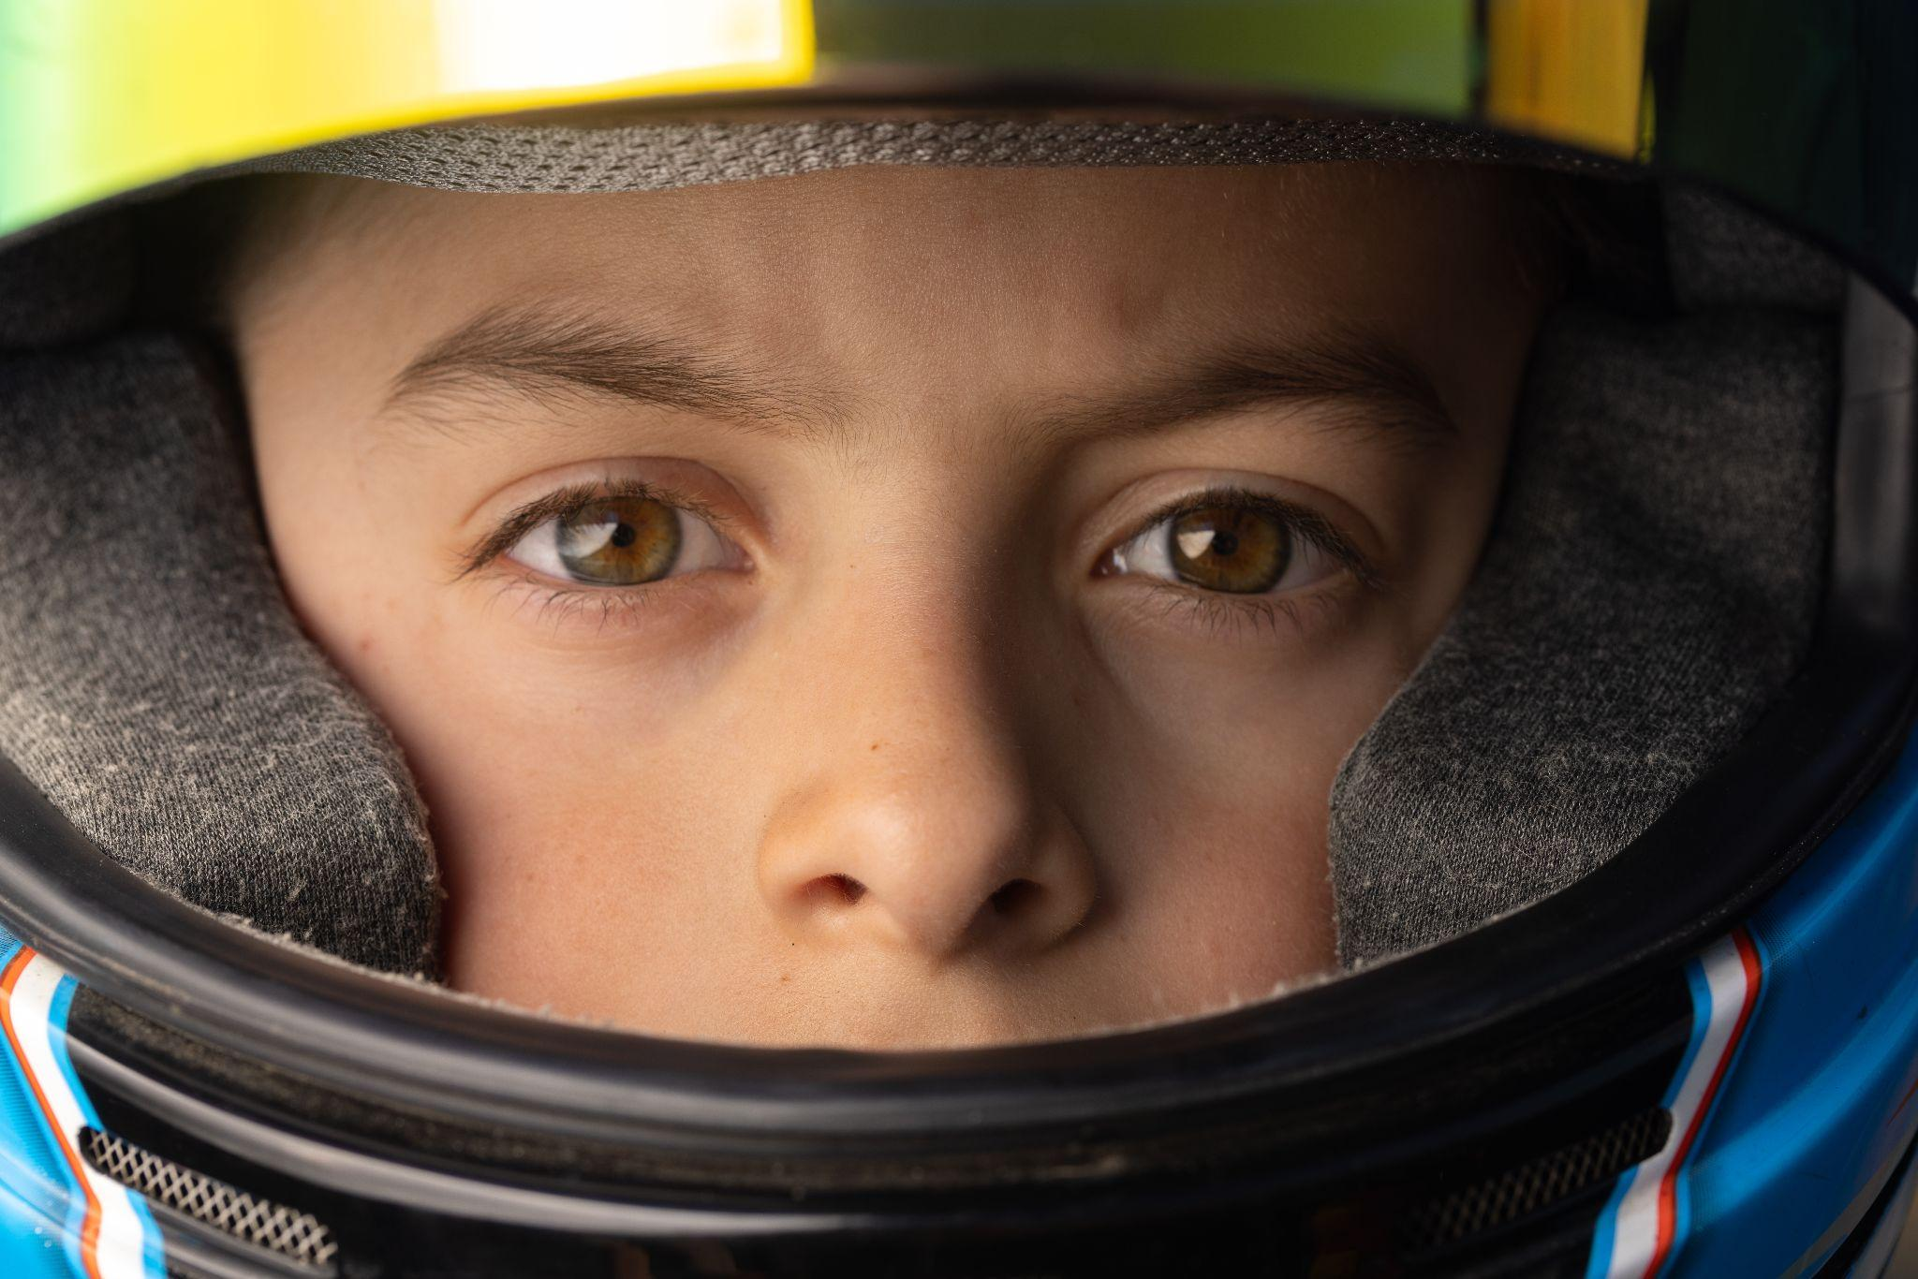  Baby Drivers
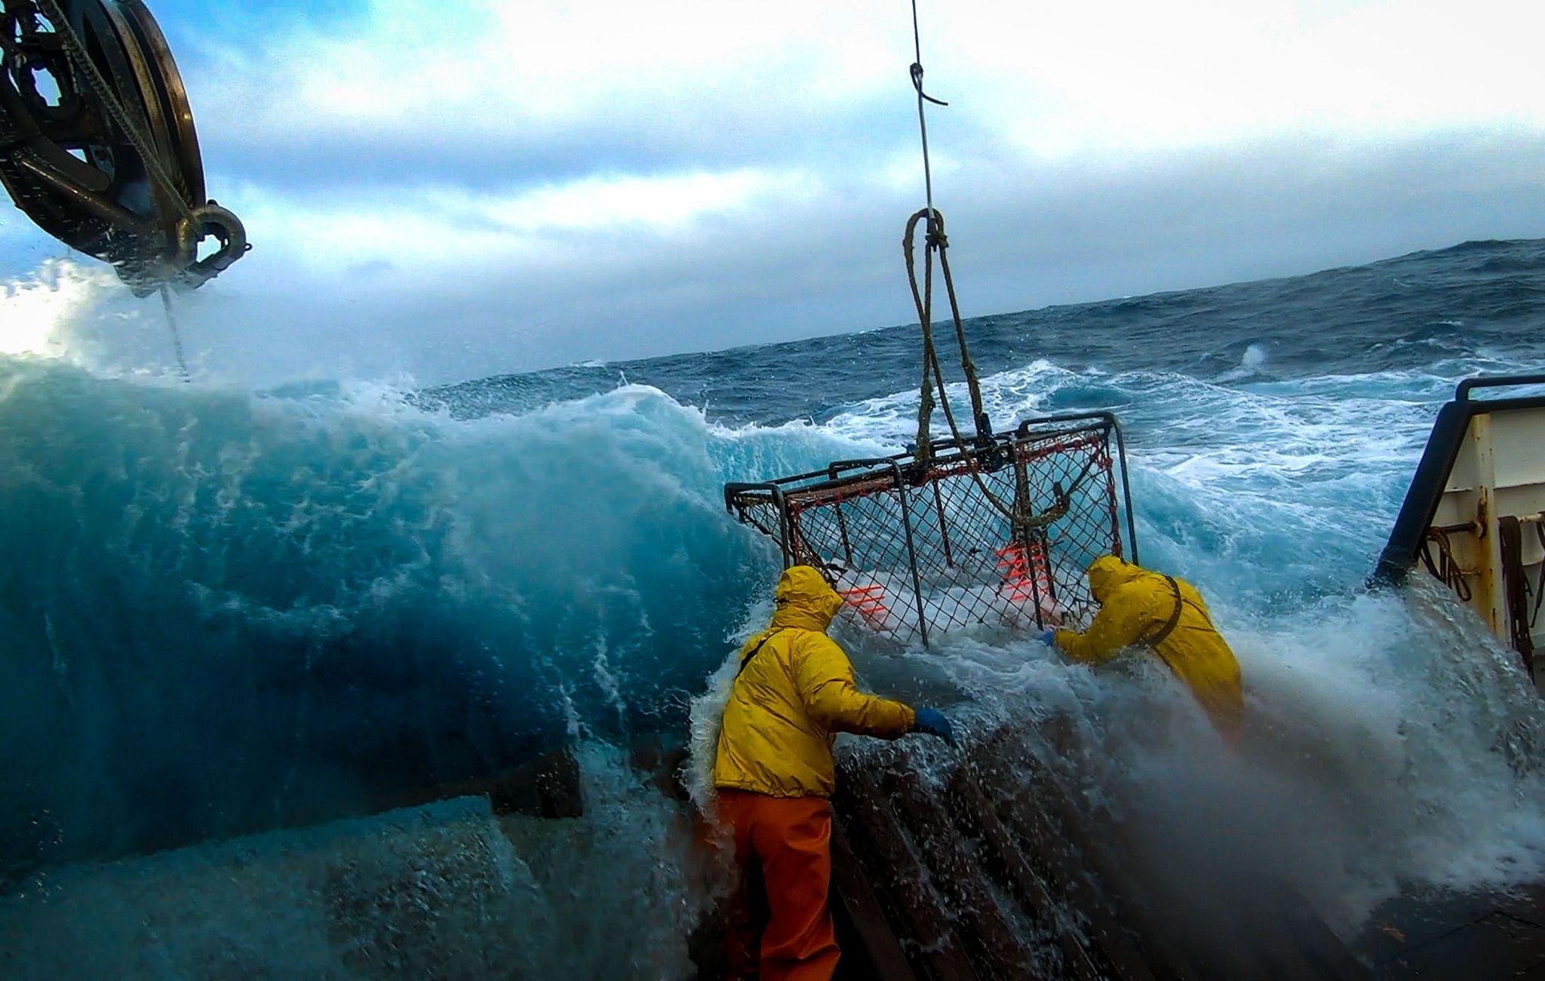  Deadliest Catch 18 | 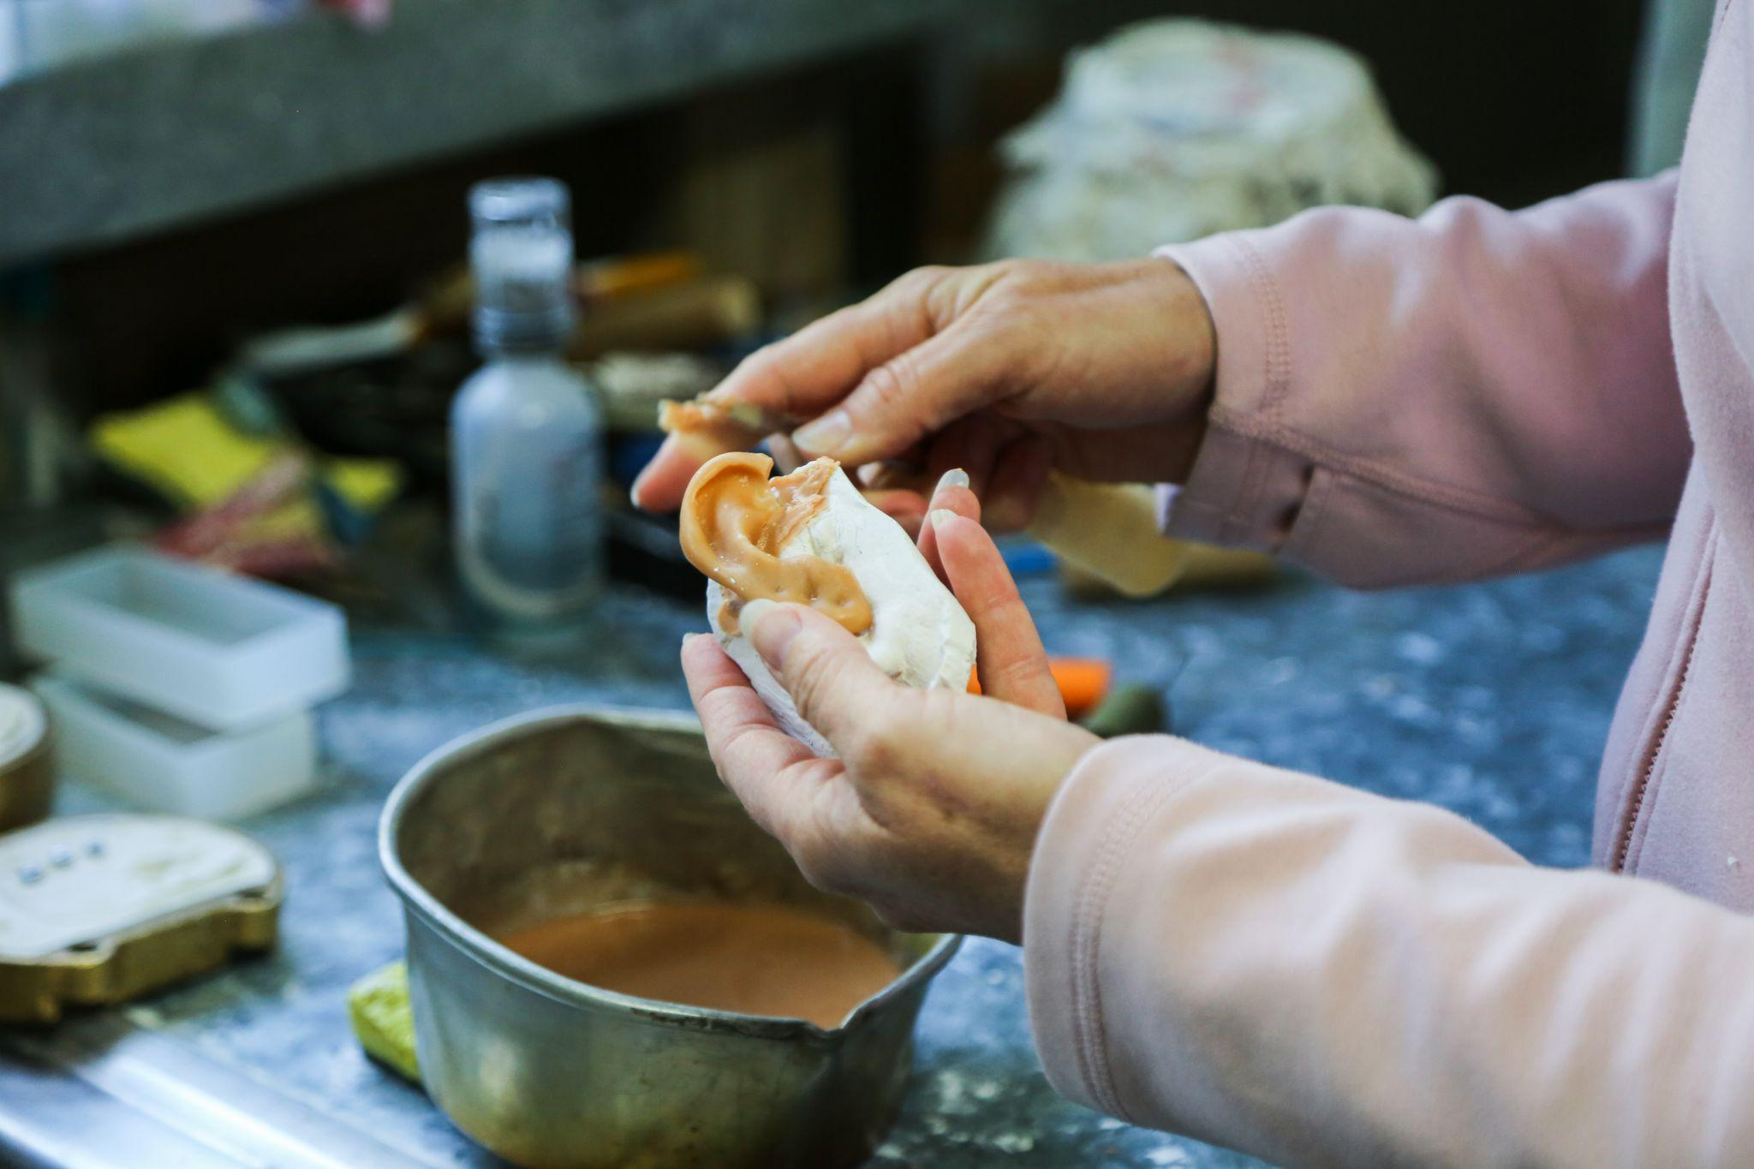  Body Parts
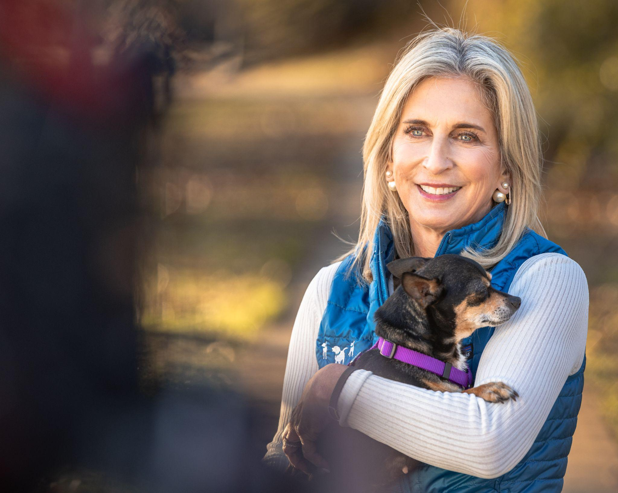  Puppy Bowl XVIII Pre-Game Show | 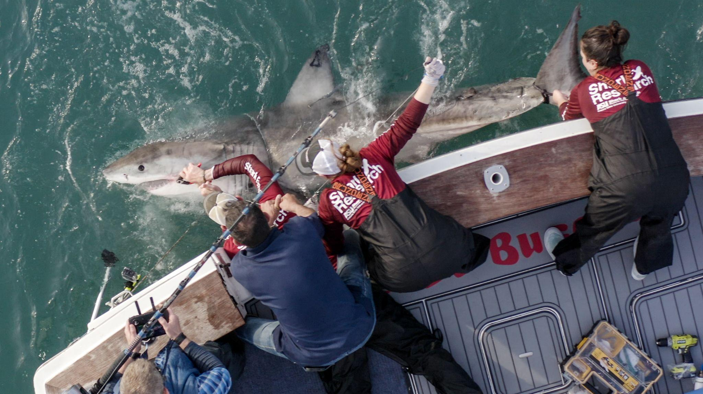  SW22: The Haunting of the Shark Tower
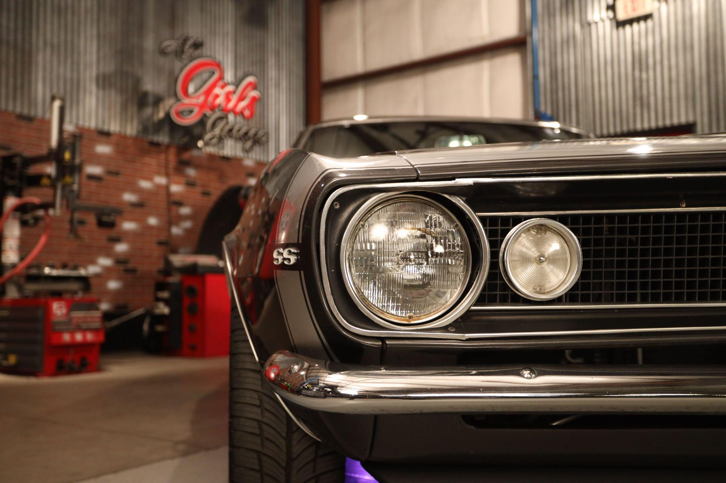  All Girls Garage 11 | 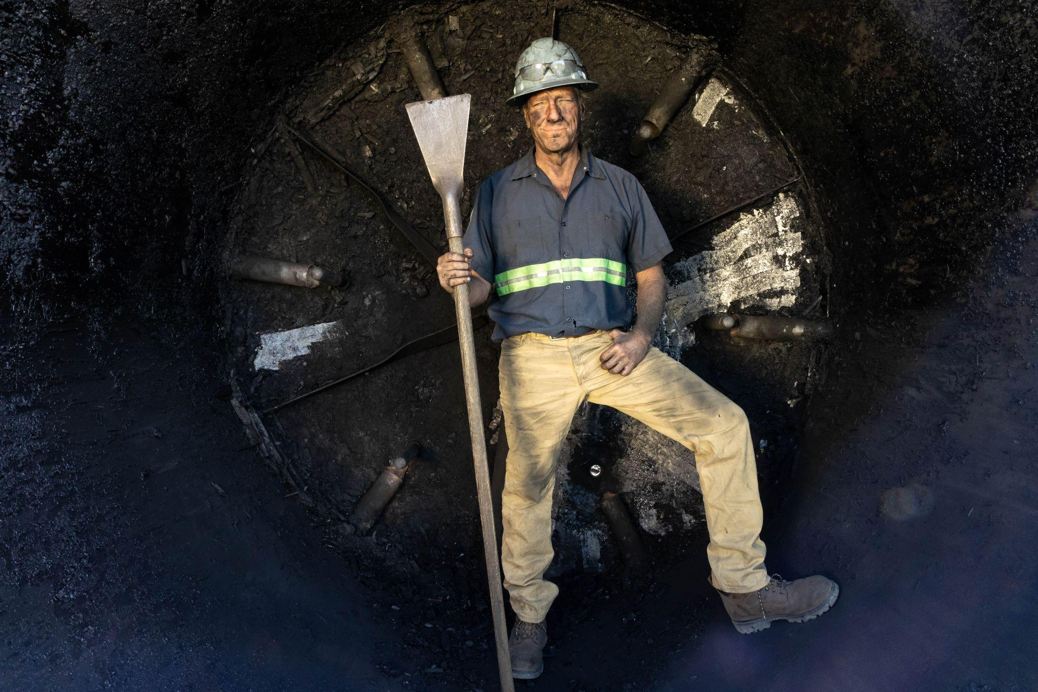  Dirty Jobs 9
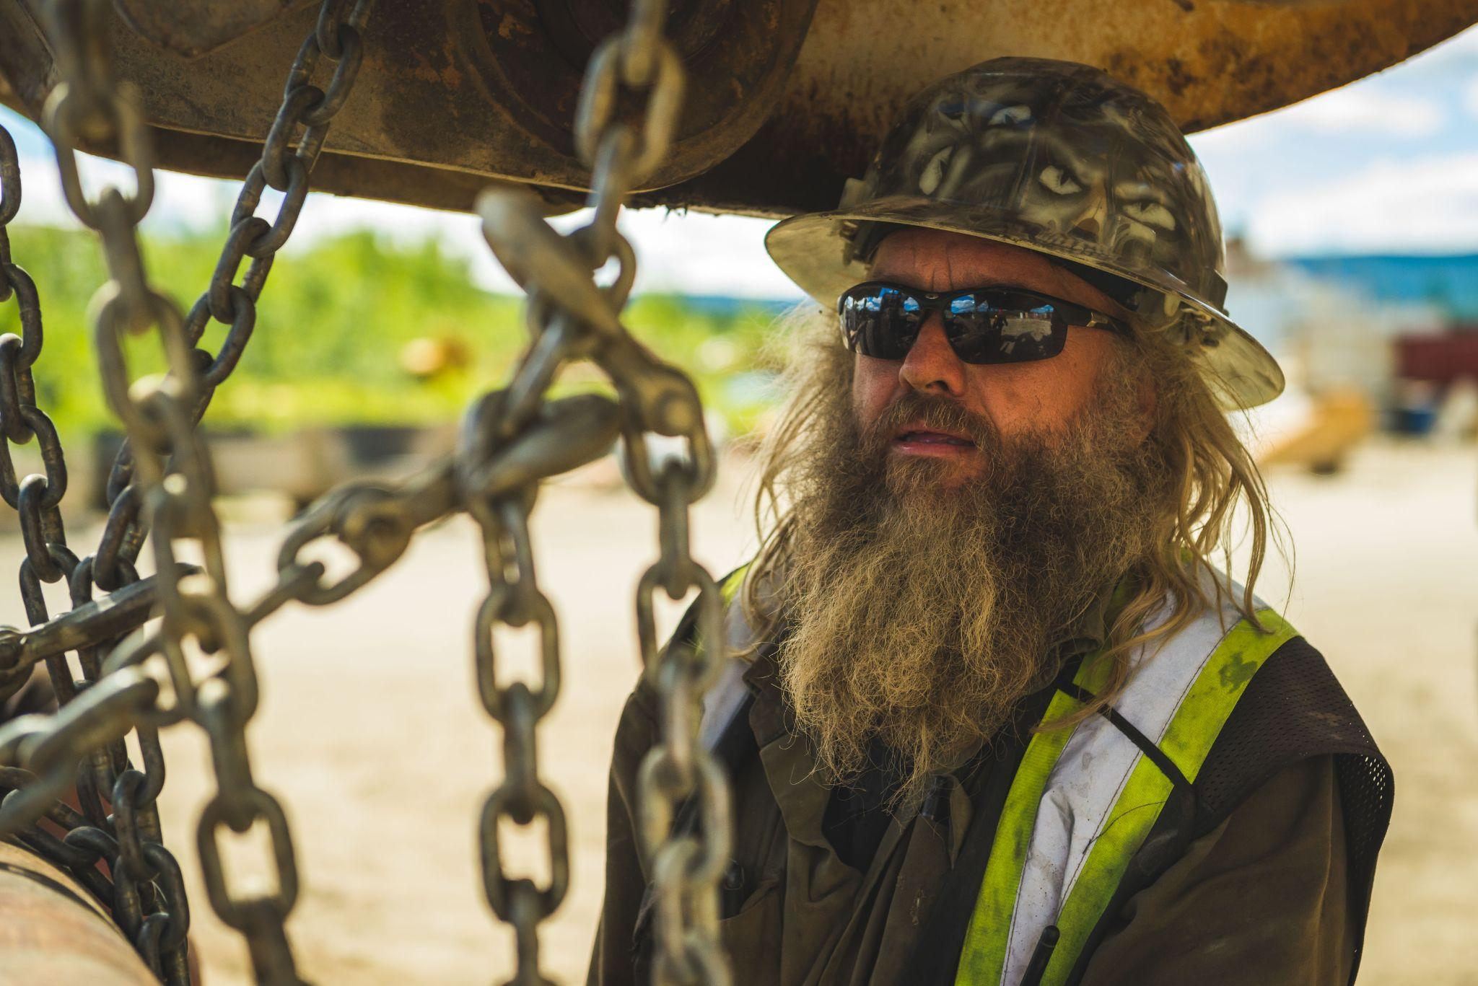  Gold Rush 12 | 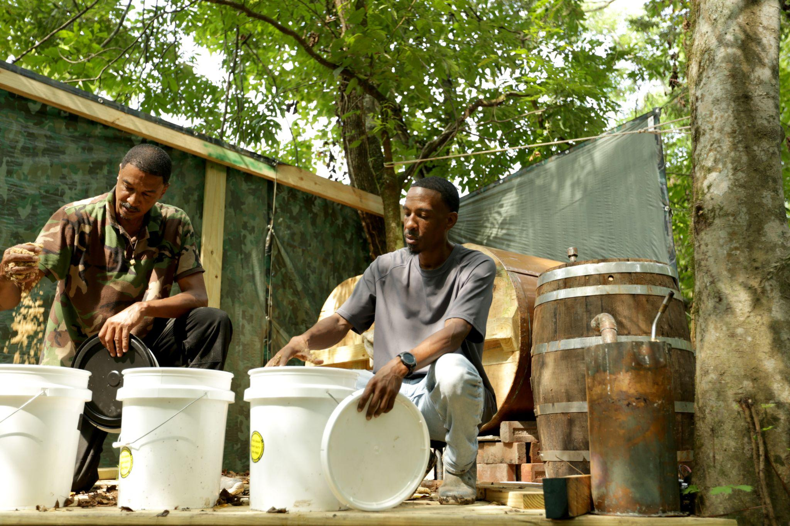  Moonshiners 11
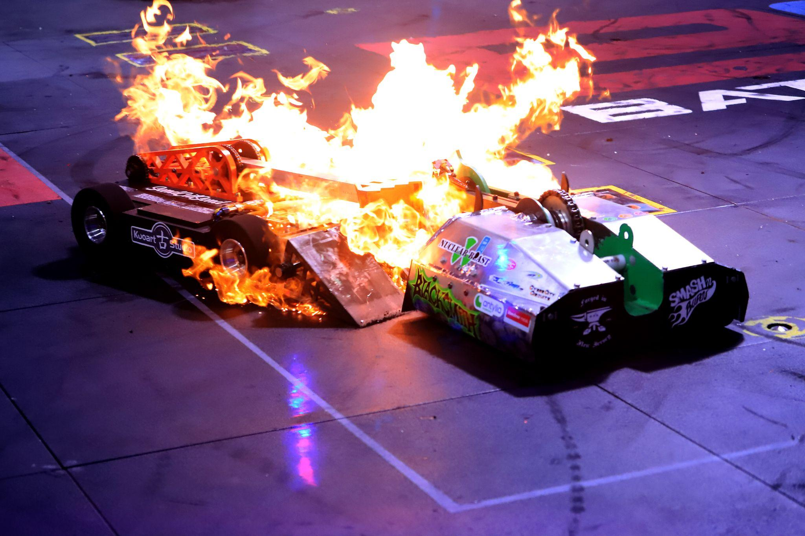  Battlebots 6 | Big 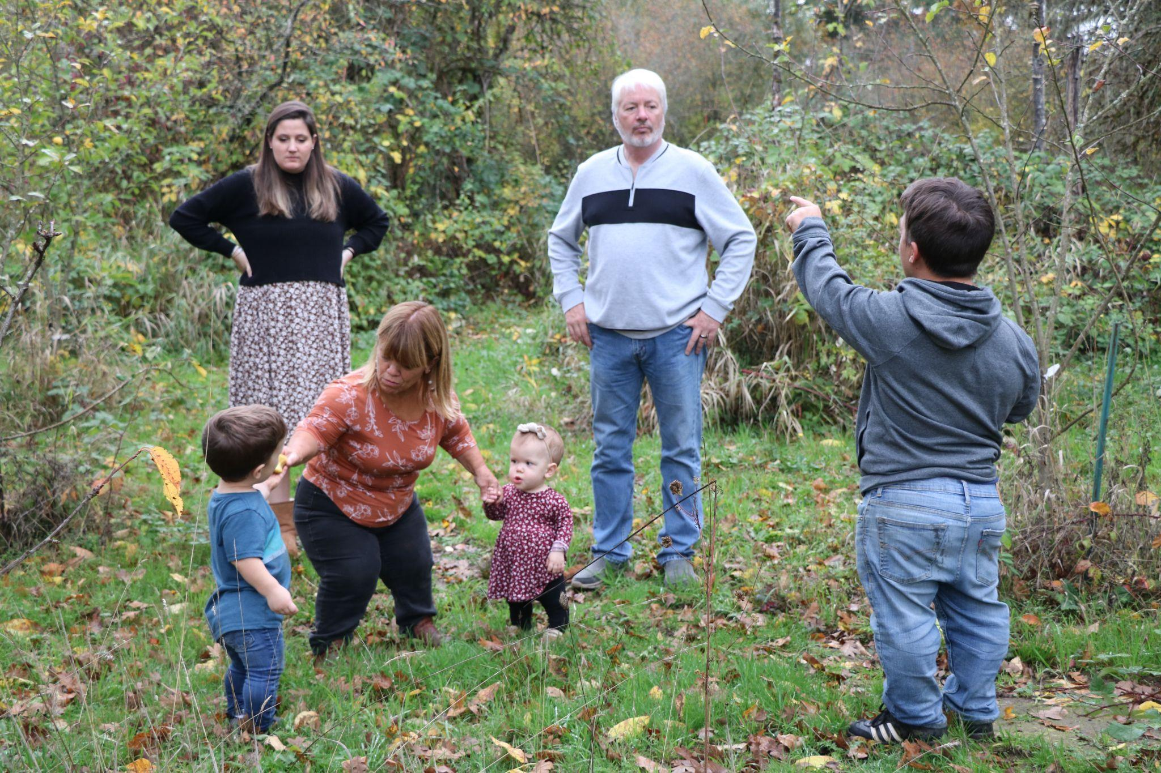  Little People, Big World 15

